Role of Mental Stress in Poly Cystic Ovarian Syndrome (PCOS)

Dr Bindu.B.R
,Lecturer,Dept Of Organon Of Medicine,Shree Vidyadhiraja Homoeopathic Medical College,Nemom,Trivandrum,Kerala,India

DEFINITION
PCOS is a common disorder, often complicated by chronic anovulatory infertility and hyperandrogenism with the clinical manifestation of oligomenorrhoea, hirsutism and acne.
The National Institutes of Health (NIH) 1990 preliminary consensus definition has now been replaced by a more recent definition by the Rotterdam European Society for Human Reproduction and Embryology (ESHRE) and the American Society of Reproductive Medicine (ASRM) PCOS Consensus Workshop Group.
This has suggested a broader definition for PCOS, with two of the three following criteria being diagnostic of more recent definition by the Rotterdam European Society for Human Reproduction and Embryology
The condition:
● Poly cystic ovaries (either 12 or more peripheral follicles or increased ovarian volume (greater than 10 cm3 )
● oligo- or anovulation
● Clinical and/or biochemical signs of hyperandrogenism.

Agenda
1. Increasing incidence in PCOS
Polycystic ovary syndrome (PCOS) is recognized as one of the most common endocrine/metabolic disorders of women. Its prevalence depends in part upon the diagnostic criteria used to define the disorder. As an example, in a report of 827 women with World Health Organization class II oligoovulation (euestrogenic normogonadotropic ovulatory dysfunction), 456 (55 percent) were classified as having PCOS by the National Institutes of Health (NIH) 1990 criteria (irregular menses, biochemical and/or clinical hyperandrogenism, and other causes of hyperandrogenism excluded). In contrast, 754 (91 percent) women were considered to have PCOS using the Rotterdam 2003 criteria (which requires two out of three of the following: oligo- and/or anovulation, clinical and/or biochemical signs of hyperandrogenism, and polycystic ovaries [by ultrasound]). Other causes of hyperandrogenism must also be excluded for the Rotterdam criteria.
General population — To date, the prevalence of PCOS has been determined primarily using the NIH 1990 criteria. A similar prevalence between 6 and 12 percent has been reported in the following populations:

Stress in women
- Women are more likely than men (28 percent vs. 20 percent) to report having a great deal of stress (8, 9 or 10 on a 10-point scale).
- Women are more likely to report physical and emotional symptoms of stress than men, such as having had a headache (41 percent vs. 30 percent), having felt as though they could cry (44 percent vs. 15 percent), or having had an upset stomach or indigestion (32 percent vs. 21 percent) in the past month.
- Married women report higher levels of stress than single women, with one-third (33 percent) reporting that they have experienced a great deal of stress in the past month (8, 9 or 10 on a 10-point scale) compared with one in five (22 percent) of single women. Similarly, significantly more married women report that their stress has increased over the past five years (56 percent vs. 41 percent of single women). Single women are also more likely than married women to say they feel they are doing enough to manage their stress (63 percent vs. 51 percent).
- Married women are more likely than single women to report they have experienced the following due to stress in the past month: feeling as though they could cry (54 percent vs. 33 percent), feeling irritable or angry (52 percent vs. 38 percent), having headaches (48 percent vs. 33 percent) and experiencing fatigue (47 percent vs. 35 percent).
Men and women report wide gaps between determining what is important and how successful they are at achieving those behaviors.
- Women are much more likely than men to say that having a good relationship with their families is important to them (84 percent vs. 74 percent). While fewer women say they are doing a good job at succeeding in this area, they outpace men (67 percent vs. 53 percent).
- Women are also more likely than men to say that having a good relationship with their friends is important to them (69 percent vs. 62 percent), even though friendship is cited less often than family for both men and women.
- Even though nearly half of all women (49 percent) say they have lain awake at night in the past month because of stress, three-quarters of women rate getting enough sleep as extremely or very important (75 percent compared with 58 percent of men).
- Across the board, men’s and women’s perceptions of their ability to succeed in areas that are important to their well-being are far out of line with the importance they place on these behaviors. Even more so than women, men report less likelihood of success in these areas.
• Only 33 percent of women report being successful in their efforts to get enough sleep (compared with 75 percent who believe this is important); only 35 percent report success in their efforts to manage stress (compared with 69 percent who believe this is important); 36 percent report success in their efforts to eat healthy (compared with 64 percent who believe this is important); and only 29 percent are successful in their efforts to be physically active (compared with 54 percent who believe this is important).
• Only 25 percent of men report being successful in their efforts to get enough sleep (compared with 58 percent who believe this is important); only 30 percent report success in their efforts to manage stress (compared with 59 percent who believe this is important); only 25 percent report success in their efforts to eat healthy (compared with 52 percent who believe this is important); and only 26 percent are successful in their efforts to be physically active (compared with 54 percent who believe this is important).

oligo- or anovulation
  - Hypo thalamic Amenorrhea
Hypo thalamic dysfunction results in decreased or inhibited GNRH secretion which affects the pulsatile release of LH and FSH causing anovulation. A common cause of amenorrhea is functional hypothalamic amenorrhea. It is characterized by abnormal hypothalamic GnRH secretion, decreased gonadotrophin pulsations, low/normal LH concentration, absent LH surges, abnormal follicular development and low estradiol. Serum FSH concentrations are usually in the normal range with high FSH
LH ratio. Functional hypothalamic amenorrhea can be caused by eating disorder exercise or high levels of prolonged physical or mental stress .This can also include major psychiatric disorders such as depression.
2. Hyper androgenism- Hirsuitism-distribution of coarse hair in female, upper lip ,chin ,chest ,lower abdomen ,thigh due to hyper secretion of testosterone.
Androgens are steroid hormones synthesized and secreted directly by the adrenal glands and gonads. Potent androgens are also converted from precursors in peripheral tissues, including skin and fat cells.
The ovaries and the adrenals secrete the androgen pre hormones, androsteredione (A) and ehydroepiandrosterone (DHEA) under the control of LH and adrenocorticotrophic (ACTH),respectively. DHEA sulphate is secreted almost exclusively by the adrenals. Testosterone (T) is secreted by the ovaries and the adrenals and is produced by the peripheral conversion A and DHEA
In the ovary androgens are the precursors of estrogen production and their production is under the control of LH. Thus feed back control of ovarian androgen is mediated by the effects of androgen metabolites (estrogen on hypothalamus and the Pituitary .In the adrenal cortex, androgen production is under the control of adrenal androgen. Secretion is mediated by cortisol feedback on the hypothalamic-adrenal axis.
Biologic availability of androgens is related to the concentration of high affinity androgen binding protein produced by the liver known as Sex Hormone Binding Globulin (SHBG). Only free androgens and those non specifically bound to circulatory albumin are able to enter tissues and produce biologic effects.SHBG has the great affinity for DHT, then for testosterone and the E2(estrogen).
3. OBESITY
Increased secretion of gluco cortico steroids affects the fat metabolism causing lipolysis, hyperlipidaemia and cholestraemia
4 HYPERGLYCEMIA

Control by anterior Pituitary-Through effects of growth hormone, prolactin, ACTH and TSH.GH inhibits the uptake of glucose into muscle and adipose tissue and enhances release of fatty acids from depot lipids and in addition inverses the release of glucose from liver. Control by adrenal cortex glucocortico steroids prevents the utilization of glucose in muscle and adipose tissue.
PATHOGENESIS OF PCOS

Poly Cystic ovary develop when the ovaries are stimulated to produce excess amounts of male hormones(androgens),particularly testosterone, either through the release of excessive luteinizing Hormone(LH) by anterior pituitary gland or through high levels of insulin in the blood(hyperinsulinaemia) in whose ovaries are sensitive to this stimulus.
The elevated insulin levels contribute to or cause the abnormalities seen in the hypothamic-pituitary ovarian axis that lead to PCOS. Specifically, hyper insulinaemia increases GnRH pulse frequency LH over FSH dominance, increased ovarian androgen production, decreased follicular maturation and decreased stimulation.
GENERAL ADAPTATION SYNDROME
This is a mechanism as to how the stress, strain toxin etc act on our body.
Stress+ Strain –cerebrum-Hypothalamus
From Hypothalamus- 3 possible ways
  - Hypothalamus-Anterior Pituitary- Other glands and organs especially ACTH-Adrenal Cortex
  - Hypothalamus-Sympathetic-Adrenal medulla to other tissues ,organs and glands especially to Anterior Pituitary-increased ACTH to Adrenal Cortex
  - Hypothalamus-Parasympathetic-Insulin-peripheral action of Corticosteroid hormones
Whole process is called Selye as General Adaptation Syndrome

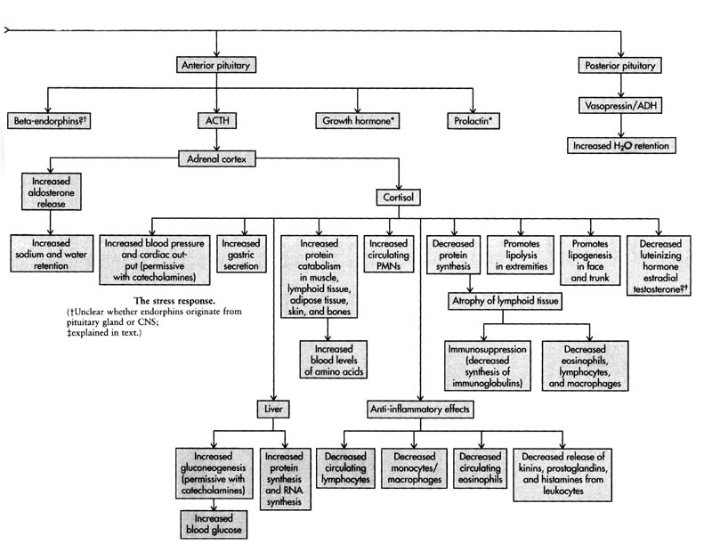

CONCLUSION
From these we can say that pathogenesis of PCOS is linked with General Adaptation Syndrome and how can stress cause PCOS for further evidence. I have taken 3-4 cases of mine with PCOS.

CASES
Case 1
An ophthalmologist of 27 years presented with a scan report suggesting of Poly Cystic ovaries along with irregular cycles once in 2or 3 months and increased growth of hairs on face especially on upper lip and chin. Other complaints include thinness of sole skin with sensitiveness and dryness which prevents her from walking without applying Vaseline continuously. Desires sweets, thermally hot, cannot hold her emotions and very difficult in taking decisions her own.
On taking the history in detail she told me that she was taking anti depressants and was continuously under mental stress especially after puberty when she was not getting her periods regularly, her orthodox family were concerned about this as she may not conceive in her entire life. And also there were continuous family stress which she doesn’t want to go deeper but acknowledged for which she was on antidepressants.
After taking the case Pulsatilla 200/1 dose was given in 2 weeks interval and she got her periods next month .Continuing treatment ,I shared this case as this was the most recent case for which I started treatment since 1 month.
Case-2
A seventeen year old girl presented with irregular menses once in 2-3 months ,increased hair growth on chin and upper lip, and a scan report diagnosed with poly cystic ovaries. Other symptoms include dandruff, hairfall, acne and allergic rhinitis.
The girl is highly ambitious in nature gets depressed whenever she gets a low mark in exams, works overnight, chilly patient’s desire for warm food and drinks likes covering. And when taken the case in detailed she had continuous mental tension
Which was due to the quarrelling of her parents and the father is of bossy type suspecting mother and her not allowing her to sing in chapel etc. Nux Vom 200/1 dose in two weeks interval followed by Nux Vom 1M/1 dose in 1 month interval was given and the periods became regular with decrease in dandruff, hair fall and acne. A follow up scan was taken which showed normal ovaries.

Case-3
A relative of mine presented with increase in weight, irregular menses once in 2 -3 months, increased hair growth on face and a scan report with bilateral Polycystic ovaries. She was 31 years of age and was trying for second child but not conceiving. Case history revealed history of mental tension in family especially with the mother in law and her husband who was abroad is of suspicious nature and quits his job frequently. So she was taking tuition to support the family but the nature of mother in law was very difficult to adjust with.
Hot patient with a desire for salted mango/sour things, increased sweat, cannot sleep without fanning and has love for pets.
Medorrhinum 200/1 dose was given in 2 weeks interval followed by Med 1M/1 dose repeated in 1 month interval and after that medorrhhinum 10 M/1 dose was given and she conceived and has a girl of 2 years now.
Case 4
A private school teacher 33 year old friend of mine presented with a scan report of bilateral polycystic ovaries and increased hair growth on face, obesity and irregular menses in 3-4 months. She was under constant stress of building home and related financial and family issues.
Patient is very friendly by nature takes pain to keep relations and emotionally keeps her anger and when it reaches a limit she explodes which she was not able to control. Desires spicy food. Has a history of recurrent urinary infections and styes.
Staphysagria 200/1 dose was given at 2 weeks interval followed by 1M at 1 month interval and the periods became regular.

